**Rest API Headers**

The Rest headers are an important part of the API request and response as they represent the meta-data associated with the API request and response.

We use REST API headers to represent the meta-data associated with an API request and response.

If we encounter issues with an API, the first place we should look is the headers, since they can help us to track down any potential issues.

**Examples of API Headers**

Here are some of the most common API Headers we will encounter when testing any API.

**Authorization:** Contains the authentication credentials for HTTP authentication.

**WWW-Authenticate:** The server may send this as an initial response if it needs some form of authentication before responding with the actual resource being requested.

**Accept-Charset:** This header is set with the request and tells the server which character sets (e.g., UTF-8, ISO-8859-1, Windows-1251, etc.)

are acceptable by the client.

**Content-Type:** Tells the client what media type (e.g., application/json, application/javascript, etc.) a response is sent in.

**Cache-Control:** The cache policy defined by the server for this response,

a cached response can be stored by the client and re-used till the time defined by the Cache-Control header.

**X-Http-Method :** Specify the http request method.

**X-RequestDigest :** Request digest is a client side “token” to validate posts back to SharePoint to prevent attacks where the user might be tricked into posting data back to the server. The token is unique to a user and a site and is only valid for a (configurable) limited time.

**If-Match :** This is used for concurrency control. To avoid concurrency. Like if we click in the update button at the same time it wont allow others to update for same time. It basically matches * with the .net frameworks

**Master Page and Site Page**

**SharePoint Master Page:**

**Master Pages:** Master pages provide the look and feel and standard behaviour that we want for all of the pages in our site. Together with content pages, they produce output that combines the layout of the master page with content from the content page.

SharePoint master pages provide the interface and overall layout of the pages on a SharePoint site. The common elements of a page – its header, navigation links, Site Actions menu, footer and so forth they are placed in the same areas regardless of the page you’re viewing.

**Site pages:** Site pages are pages that are created, edited, and customized by end users. They are primarily used for the content in a site. Site pages come in two types🡪1.) a wiki page and

2.) a Web Parts page.

* A wiki page contains text, images, Web Parts, and other elements.
* A Web Parts page contains Web Parts in Web Part zones. Web Part have a predefined layout that uses Web Part zones. Both types of site pages are edited using a Web browser or Microsoft SharePoint Designer. 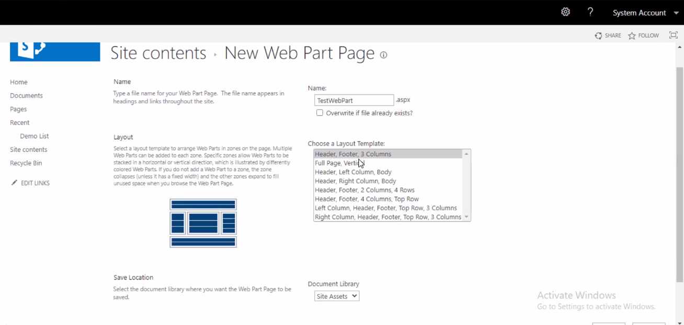
* Template for the page is stored in the content database. The page is retrieved from the content database every time it is requested by a user.
* A customized page can, however, be reset to the original template page through the Web browser or a tool such as SharePoint Designer.
* Customized site pages cannot contain in-line server code.
* These Pages are stored in the Content Database and they are parsed when requested by user.
* They can be edited, modified by the Power Users and customized according to their needs.

**Pages Extension**

* Master page 🡪 .master
* Site page 🡪.ascx
* Solution🡪 Frontend 🡪.ascx

Backend .ascx.cs